RISE OF THE SUPERHERO-NOIR

WHAT IS NEO-NOIR?
To first get a sense of what the neo-noir is, we must first define the ‘noir.’

The film noir is hallmarked by pessimism, existentialism, and the lone hero. Corruption, dastardly crime around every corner, and a lone femme fatale lying in wait for the protagonist. Much like its name, noir, which is french for ‘black,’ there is a sense of chasing dark shadows, both in the metaphorical and the literal film style. The heart of noir lies in the city: in her people, and the corruption lining it (especially in law enforcement, but is also present with most people concerning power and hierarchy), and the iconic chiaroscuro lighting that accompanies it.

It explores “a new psychological dimension, a morally ambiguous hero, a convoluted time structure and the use of flashbacks and first person narration.” (Porfirio, 80) All of which became film noir conventions. The neo-noir is a revival of these ideas and themes, but with modern conventions added to the context.

RISE OF THE SUPERHERO GENRE
The superhero genre in film as we know it today is relatively new, with its generous use of CGI and intense, possibly world-ending stakes, having truly taken off in popularity in the early 2000s. There are a couple of factors that have attributed themselves to this dramatic increase of popularity, which one New York Film Academy article points out has to do with the age of the viewer base. Comic fans, having grown up with them (especially after their rise in demand during both WWII and another explosion of popularity in the 90s), will already be anticipatory in seeing their childhood on the big screen, backed with the wealth that comes with adulthood and having a job to call their own. Capitalizing on this suddenly becomes much easier with the introduction of fan favorites, casted by popular celebrities of the day.

This, coupled with the recession in 2008 which led to a huge boom in popularity, has firmly cemented the superhero film genre as a hallmark of 21st-century film. People want escapism— to see a bleak world saved by their childhood heroes, to see that there is justice and something worth saving, and to perhaps sit back, relax, and watch some thrilling action.

Two major powerhouses in the industry rose, turning into digital what was once on paper: DC Comics and Marvel Comics. These two are the ones that we will be taking a look at today, and how they’ve adapted aspects of the classic film noir to suit their needs— and, it has to be said, they do fit together quite well. There may be a spot for a revival or ‘renaissance’ of noir in the superhero genre, should trends continue.

BATMAN AND THE NEO-NOIR
Christopher Nolan, while not the director of all Batman films, is the director of the films we are going to be talking about today. Nolan is the director of the DC trilogy of Batman films, Batman Begins (2005) The Dark Knight (2008) and The Dark Knight Rises (2012), which were a huge success, and a take on the neo-noir.

Nolan has been influenced heavily by both the classic noir and the neo-noir, with him citing Double Indemnity (1944) as reference and inspiration for several of his other works, (McAndrew, 2021) and although his work on the Batman series certainly has more aspects of Hollywood due to, well, it being such a large project it certainly carries the mantle of the neo-noir very well. It’s visible even from simply looking at the movie posters: the angles and dramatic lighting and silhouette in Batman Begins, and the promise of violence and lighting for The Dark Knight, as well as the title itself.

The Batman (2022), while not a Nolan film, continues the legacy of Batman and the neo-noir that he began, showing the significance of Nolan’s influence on the series.


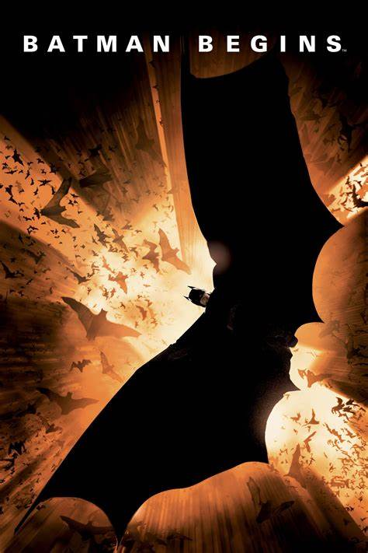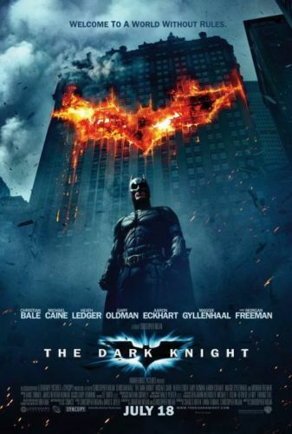

BATMAN BEGINS (2005)
“It is night, always. The hero enters a labyrinth on a quest. He is alone and offbalance. He may be desperate, in flight, or coldly calculating, imagining he is the pursuer rather than the pursued…”
-Christopher, Into the Labyrinth (7)

…It is night, over Gotham City, full of corruption and crime and violence. The stars aren’t able to be seen beyond the light pollution, and a lone figure stands over the skyline of the city, on a mission. He is alone and offbalance, coined the ‘world’s greatest detective,’ and believes himself the pursuer rather than the pursued.


The character of Batman is one that embodies ‘noir’ in a great number of aspects. He is the classic hard-boiled detective (or, rather, a mixture of both the classic and the hard-boiled detectives, fighting crime by night and planning his next five moves by day), jaded by his years of existence and inherently alone—by choice or by circumstance—because of it. This job, his mission is one only he can complete due to his unique skills (being Batman, and also being a billionaire able to fund his crime-fighting endeavors out of pocket) and need for vengeance for the tragic murder of his parents in front of him.

Batman Begins (2005) Official Trailer #1 - Christopher Nolan Movie

The start of a trilogy of Nolan films, Batman Begins sets up not just the film style, but the narration style and themes of the rest of the trilogy. Batman Begins has been heralded because of its deep psychological storyline about Bruce Wayne’s origins as Batman, and his fight against Ra’s Al Ghul and Scarecrow (two recurring villains in the DC-verse, with the former focused on immortality and the latter on exacerbating the fears of his victims).

THE DARK KNIGHT (2008)
The origin of the name The Dark Knight came from a Batman miniseries by Frank Miller in 1986, who used iterations of ‘The Dark Knight’ in each of his titles. It quickly became a way to refer to the character of Batman without explicitly saying ‘it’s Batman!’ like Superman’s ‘man of steel,’ or Spider-man’s ‘friendly neighborhood spiderman,’ or even the iconic ‘Avengers Assemble!’ from Marvel. It’s become synonymous with Batman over time, and even the title of the hit 2008 film directed by Christopher Nolan, which certainly lives up to the name in terms of ‘darkness’ and Batman acting as a knight of justice.

This film follows the origin-story of Two Face, a DC villain who was once a politician (and, for most of the course of this film, is one) before an accident leaves half of his body burned beyond recognition, and an intense hatred for Batman. His trademark coin–his ‘lucky coin,’ as he calls it–decides the fate of his victims.

Yet, he wasn’t always this way. Ironically enough, he is referred to in the film as the white knight (and no, not in the way we think of it today as slang. In the DC universe, it symbolizes the righteous law and justice, which fits the district attorney). The antithesis to Batman’s ‘dark knight,’ who works outside of the law and envelops himself in violence as his manner of justice, and yet is someone that Batman remarks that he admires and respects greatly multiple times throughout the film.

I Am The Batman - Dent l The Dark Knight (2008)

This, perhaps, makes Harvey Dent’s (Two Face) fall from grace into one of the villains he was initially trying to rid the city of so impactful. He was Gotham’s hope for a brighter future, but was unfortunately unable to overcome the corruption of the city. The video below foreshadows this, but beware of flashing lights!

Harvey Dent Interrogates The Joker's Thug Scene | The Dark Knight (2008) Movie Clip 4K HDR

Harvey represents the idea of corruption that film noir loves to play with so much: after all, what is more ironic than the proclaimed epitome of justice by Batman himself becoming the evil he sought to destroy. It’s almost nihilistic, were it not for the fact that longtime comic fans would already know the origin story, and other audience members could be comforted with the fact that Batman’s morals are steadfast. Existential, for sure, which is another hallmark of noir film narrative.

The Dark Knight checks a lot of the narrative ‘boxes’ of film noir, as well as the visual ones. Although, that’s perhaps to be expected considering Nolan directed this film as well as Batman Begins. All three films in the trilogy near abuse chiaroscuro and low-key setups, with night-for-night shooting and a love for extreme angles. A reflection of its director, both Batman Begins and The Dark Knight share the same checklist.

DAREDEVIL AND THE NEO-NOIR (2015-2018)
Marvel studios, as mentioned before, has a history just as deep as DCs, and are distinctly different from their rival-studio in terms of the themes of their superhero movies. Both are full of action and captivating battle sequences with high stakes, as is expected by their target audience, but whereas DC focuses more on standalone films— Batman, Superman, Wonder Woman with the occasional crossover such as Justice League or Batman versus Superman—Marvel’s fame comes from their cinematic crossovers such as the Avengers series, which is almost ‘supported’ by their standalone series such as the Iron Mans or Spider-Mans that add context, instead of the other way around. As well, Marvel studios tends to be lighter than DC, whose characters tend to embody struggle and conflict as personal themes, compared to Marvel who tends to have more one-liners and comedic moments interspersed through to lighten the mood. The film style also tends to incorporate this, where DC films tend to be less saturated and/or exposed whilst Marvel films use intentional color theory with bright, saturated colors.

One of the main exceptions from the Marvel rule is the 2015 series Daredevil, which features superpowered blind lawyer Matthew Murdock and his legal team as he tries to navigate the corruption, gangs and drugs of the city. His superpowers were augmented when he lost his sight, and enhanced his other senses to the point where he acts like a human polygraph machine.

The balance between Murdock— attorney at law, and upholder of justice the legal way—and the devil of Hell’s Kitchen, who’s ruthless and works outside of both the law and police (and earns a very controversial public opinion because of it), are what makes this series so dynamic. The characters of the detective and lone hero, while still contained within the same person, are separated by the mask to a great degree. This seems to be a common theme with a lot of the superhero films that take elements from noir; they must work outside or even against the law in order to complete their agenda, although there will always be other characters (or in this case, other sides to this character) that have a connection to it. Murdock’s mission to defend wrongly-accused ‘criminals’ as a harbinger of the law, both in and out of the mask leads directly into the narration of the story, and the discussion about corruption in the city and the best way to solve it (how, with certain characters it’s necessary to work more in or outside of the law, but the easiest— or even necessary solution is the ‘best of both worlds’ where Daredevil uses knowledge from both fields of his life).


Murdock is the epitome of Poriforo’s ‘non-heroic hero’ (Poriforo, 82), with his ruthlessness and public distaste. The show does not lean away from this to make Daredevil more likeable, but rather they dive straight in to explore with the sudden violence, grittiness and gore of (especially) the first few episodes of the show. The muted palate and desaturation of Hell’s Kitchen, and liberal use of extreme high and low angles show how Hollywood editing can combine with noir color grading and shots so well. The show was generally a success, but was eventually ultimately cancelled in 2018 due to licensing issues between Disney and Netflix (where the show was housed). Yet, the blind lawyer recently made a cameo in Spiderman: No Way Home (2021), which was warning enough for the reveal that in 2024 Disney+ plans to release their own series Daredevil: Born Again.

Who knows how closely this revival of the show will follow its original in terms of style, however the grittiness and darkness that surrounds Daredevil is something so integral to the characters of the show and comics that it’s safe to say that this neo-noir show will continue on its current path.

GREEN ARROW AND THE NEO-NOIR (2012-2020)
Arrow is another Netflix series, following the character of DC’s Starling City hero, the Green Arrow. Spanning eight seasons and eight years, we find ourselves with yet another billionaire protagonist, who wants to “bring justice to those who have poisoned my city.” He does so through checking names off of a ‘hit list’ of sorts his late father left him, of corrupt riches in the city. He makes his intentions as a vigilante and hero quite clear through his use of monologue, changing slightly between seasons but nonetheless similar at its core.

Arrow Intro Season 1


The film style is very similar to what we see in noir, with moderate-to-heavy use of flashback used liberally to help explain situations and context, as well as the use of monologuing narration to establish motivations, context, and tone. While it is used more frequently during the beginning and ends of each season, as the storyline continues (spanning eight years in the characters’ plot) so does the need to remind audience of long-ago facts or tidbits, as well as clarification to keep the plot from becoming too convoluted.

Violence is still the natural language of our cast, with dramatic lighting and dramatic silhouettes emphasizing the heavy nature of the show. The shaky camera used during many scenes—but especially the flashbacks—show the uncertainty of the world that Oliver Queen has been reintroduced into.

If Queen’s mindset hadn’t already been clear enough from the vigilantism and introduction, then perhaps his narration about his backstory and trauma would make it clearer. During the first episode he establishes himself as someone who wants to “bring justice to those who have poisoned my city”, which fits into the noir mindset (albeit of someone more willing to use violence and physical means to do so than others might otherwise) of what one might envision of a protagonist. A noble goal, although with questionable methods.

Like Daredevil, there’s also a connection to the ‘legal’ side of things with Queen’s ex-girlfriend Dinah Lance who runs a small claims office. It’s the classic case of small legal aid office versus the big bad corporation, with Dinah trying to continue her father’s philosophy that “[they] don’t need to go outside the law to find justice”, a sentiment that is disproved by Queen’s vigilantism and helping of their cases (although unknowingly) through less-than-legal means. This reiterates the idea that the corruption in the city can only be thwarted through a lone vigilante hero, working for the betterment of their city as an independent symbol of justice.

Arrow's Final Intro (Series Finale)

The show reached its conclusion in 2020 after eight seasons over eight years, and the decision seems to have been a combination of the cast wishing to leave and the COVID-19 pandemic. The finale (spoilers ahead!) is a memorial to Oliver Queen, who sacrificed his life to protect his loved ones just before the end of the season. This bittersweet ending to the show is actually something seen in quite a few film noirs– the protagonist dying at the end. However, in the classic noir it’s usually accompanied by a monologue in the beginning about how they got into this situation, Arrow’s episodic nature (and also already having a narration in the beginning) wouldn’t allow for that. The show reached a natural conclusion, one that was satisfying and that the fanbase didn’t hate, despite the final season being shorter than all the others.

RISE OF THE SUPERHEROS PT.2

The superhero genre is growing, and today makes up some of the highest grossing films, with many new shows and movies in the works. It’s only a guess as to how far it will expand, and just how many of these series/films are going to be like DC and the MCU—based off of comics—before branching off. The question for now, though, is could the superhero genre become a new foothold for neo-noir?
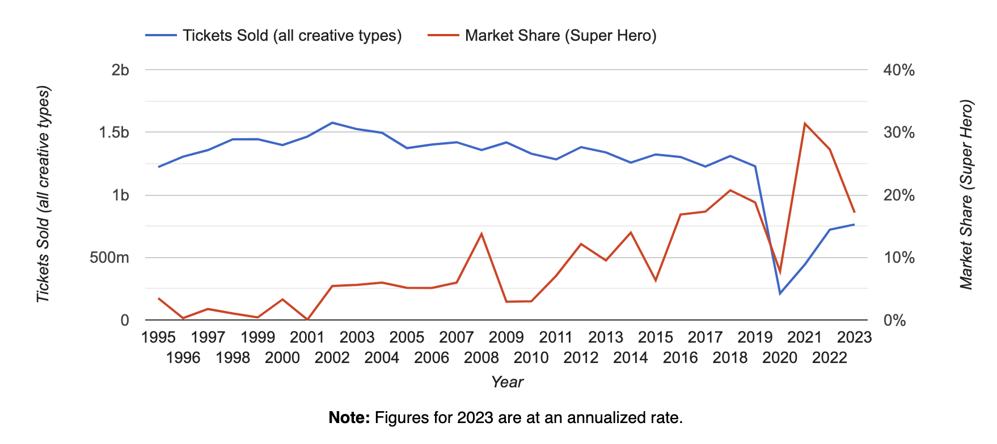
Fig. A The Numbers.com

The prevalence of the genre cannot be questioned, yet one could argue that the rise of sheer number of superhero movies being produced in general would show these same spikes. Still, it certainly shows the success of some of these films (unfortunately, the data does not directly encompass any shows, however we can safely assume they’re at least slightly correlated or linear) by comparing years.

As well, there have been more direct references to film noir in recent films, which suggests that the idea of neo-noir and the superhero is even a welcome idea. The animated film Spider-man: Into the Spiderverse (2018) even had a character called Spider-man Noir, referred to in the film as Spider-noir or Noir.

The fact that future films and shows are being not only made, but drawing upon the influence of their predecessors (The Batman in 2022, or the new Daredevil cameos and series potentially suggesting a future as a more mainstream character) shows the influence of the neo-noir on the superhero genre, and gives hope to the idea that it could lead to the revitalization of the film and narration style in a new, blended way.

WORKS CITED
American Cinematographer: Batman Begins, theasc.com/magazine/june05/batman/page2.html. Accessed 15 May 2023.
Christopher. “Into the Labyrinth.”
“Box Office Performance History for Super Hero Movies.” The Numbers, www.the-numbers.com/market/creative-type/Super-Hero. Accessed 15 May 2023.
Erdmann, Kevin. “The True Origin of Batman’s ‘Dark Knight’ Title Is Finally Explained.” ScreenRant, 28 Aug. 2022, screenrant.com/new-origin-of-batman-dark-knight-title-explained-bruce-wayne/.
Logan. “What Is the Difference between Marvel Movies and DC Movies? (The Cinematic Universe).” All The Differences, 13 Dec. 2022, allthedifferences.com/what-is-the-difference-between-marvel-movies-and-dc-movies/.
McAndrew, James. “From Double Indemnity to Heat - How Film Noir Created Christopher Nolan.” Medium, 12 Sept. 2021, jamesrobertmcandrew.medium.com/christopher-nolan-and-the-long-shadow-of-film-noir-643602196952.
Place, Janey, and Lowell Peterson. Some Visual Motifs of Film Noir. 1974.
Porfirio, Robert G. No Way Out: Existential Motifs in the Film Noir. 1976.
“The Rise of Superhero Films.” NYFA, 30 June 2017, www.nyfa.edu/student-resources/the-rise-of-superhero-films/.

